VERIFYHIRE: AI-Powered Video-Based Job Matching Platform for Blue-Collar Workers
Bathi Ramya Durga¹, Botsa Harshini², Chinta Monika Sri Manga Varshitha³, Dalli Sathvika Reddy⁴ and M. Sion Kumari⁵
¹,²,³,⁴Student, B. Tech Sem VIII, Computer Science and Systems Engineering, Andhra University College of Engineering for Women, Visakhapatnam, India
⁵Assistant Professor, Department of Computer Science and Systems Engineering, Andhra University College of Engineering for Women, Visakhapatnam, India

Abstract — VerifyHire is an AI-based platform that assists blue-collar employees in securing better job opportunities through a video-based hiring and verification process, serving as an alternative to the conventional resume-based approach. Skilled workers such as electricians, plumbers, and construction workers often face difficulties in securing jobs due to a lack of formal education, language barriers, and the absence of formal proof of skills. Employers, in turn, face difficulties in verifying candidate authenticity, leading to inefficiencies and fraud in the hiring process. VerifyHire addresses this by allowing workers to submit short video resumes describing their skills. Each video is then processed through a five-stage AI pipeline: YOLOv8 face detection verifies physical presence, DeepFace identity verification confirms the worker's identity, Faster-Whisper speech recognition converts spoken content to text, spaCy natural language processing extracts skills from the transcript, and Sentence-BERT semantic matching connects workers to suitable job postings. The system serves two primary user types: workers who build verified digital identities through video uploads, and employers who post job requirements and receive AI-ranked candidate matches. An admin panel monitors and manages overall platform activity. Testing confirmed a face detection confidence of 0.965 on real video submissions and successful end-to-end pipeline execution.
Keywords — Artificial Intelligence (AI), Video Hiring Process, Blue-Collar Workforce, Speech Recognition, Natural Language Processing (NLP), Face Verification, Semantic Matching, Machine Learning, Deep Learning, Job Recommendation Systems, FastAPI, Next.js, Sentence-BERT, PostgreSQL

I. INTRODUCTION
In modern times, where the nature of jobs is changing fast, online job boards have gained much importance for job seekers to find their potential employers. Nevertheless, all such online portals available today are tailored towards white-collar workers that have text-based resumes, while blue-collar workers — people who engage themselves in skilled professions like electricians, plumbers, laborers, and deliverymen — get neglected. There is no denying that blue-collar workers make a huge portion of the world's workforce, especially in developing nations.
There is certain inefficiency regarding traditional methods of recruiting, such as networking and informal recruiting companies. In addition, lack of formal education, issues with language, as well as poor computer literacy, do not allow workers to properly prove their qualifications. Employers, meanwhile, have trouble verifying candidates' credentials.
To overcome these issues, this paper proposes VerifyHire, an AI-driven digital platform which uses a video-based hiring methodology instead of existing resume-based approaches. VerifyHire allows job seekers to create video resumes where they can showcase their capabilities through verbal and visual communication without needing to write anything. These videos are analyzed by an automated AI pipeline which identifies candidates' identities, speech, and skills.
The system caters to two main user types: workers who create digital identities through video uploads, and employers who post job requirements and receive candidates ranked by an AI score. An admin panel oversees platform activity. Utilizing facial recognition, speech processing, NLP, and semantic job matching, VerifyHire makes the recruitment process systematic, transparent, and inclusive.
II. RELATED STUDY
A. Online Job Portals (e.g., Naukri, Monster, Indeed)
Pre-existing sites like Naukri, Monster, and Indeed are primarily targeted towards resume-oriented recruitment systems aimed at white-collar employees. Such platforms assume that candidates hold a formal education background along with a resume and certifications. Blue-collar employees find it difficult to demonstrate their practical skills through such recruitment sites.
B. Blue-Collar Focused Job Apps (e.g., Apna, Work India, Job Hai)
Recent platforms such as Apna, Work India, and Job Hai have tried to cater to the blue-collar workforce through regionally available languages and simple registration procedures. However, all of these platforms depend on simple profile information and keyword-based matching algorithms that are not effective enough in capturing the practical skills and experience of a particular worker.
C. AI-Based Recruitment and Resume Screening Systems
Today's recruitment processes make use of artificial intelligence technologies that allow resume filtering, candidate scoring, and job recommendations. Natural language processing and machine learning algorithms are used to find relevant job matches. While this technology is efficient when dealing with white-collar jobs, its limitations are obvious: blue-collar workers lack an opportunity to create good-quality resumes.
D. Skill Development Initiatives and Industry Reports
NSDC reports indicate that the majority of the workforce is working in the informal sector where the skills possessed by workers are not formally acknowledged. Studies stress the importance of having technology-driven solutions which focus more on skill-based assessments rather than educational qualifications. The integration of multimedia inputs and automated authentication tools would also make the hiring process more trustworthy and accessible.
E. Research Gap and Proposed Approach
From the literature review, it can be seen that current solutions either use text-based resumes, lack adequate skill verification mechanisms, or do not offer intelligent job matching. The proposed VerifyHire system addresses these shortcomings through video-based resumes combined with a comprehensive AI verification mechanism incorporating face recognition, speech transcription, skill extraction, and semantic job matching.
III. LITERATURE REVIEW
Several research papers and online portals have been developed in order to help blue-collar workers overcome job issues. Nevertheless, most portals do not seem to be efficient enough in order to match skills to jobs effectively. Job matching systems are an important area for research that needs to implement more advanced techniques of recommendations and skills identification [1], [2].
The popular job matching portals including LinkedIn, Naukri, and Monster concentrate mostly on white-collar professions. All of these portals rely on qualifications, educational background, and resume information. Research has shown that conventional job portals fail to capture practical skills [8].
In recent times, job search via mobile employment platforms has emerged as a way to address accessibility among workers. Location-based job search and mobile job services can increase the availability of jobs to workers having low digital literacy levels. Makkena [6] presented the idea of a location-based mobile job portal specifically for the repair service industry. Studies have found that simple-to-use platforms are more widely adopted by workers [7].
However, despite providing greater job visibility, most systems lack efficient skill verification processes and intelligent job-matching algorithms. An embedding-based approach for finding candidates and improving the matching process was discussed by researchers [2]. There is also literature that has considered the use of knowledge graphs and online job analytics for identifying labor market requirements and skill gaps [1], [3].
Modern studies have investigated how effective digital job matching platforms are at enhancing labor market results. Otani [4] evaluated matching effectiveness in online job search portals and discovered that good algorithmic matching increases employment opportunities. Contemporary recruiting methods are leveraging AI algorithms to evaluate worker abilities and job needs to offer better matching for blue-collar employees [9].
IV. MATERIALS AND METHODS
A. System Architecture
VerifyHire is structured as a three-tier system comprising a Next.js 16 (TypeScript) frontend, a FastAPI (Python) backend with asynchronous processing, and a PostgreSQL database. Authentication is handled through JWT tokens with role-based access control enforced at the API level. The system architecture is illustrated in Fig. 1.
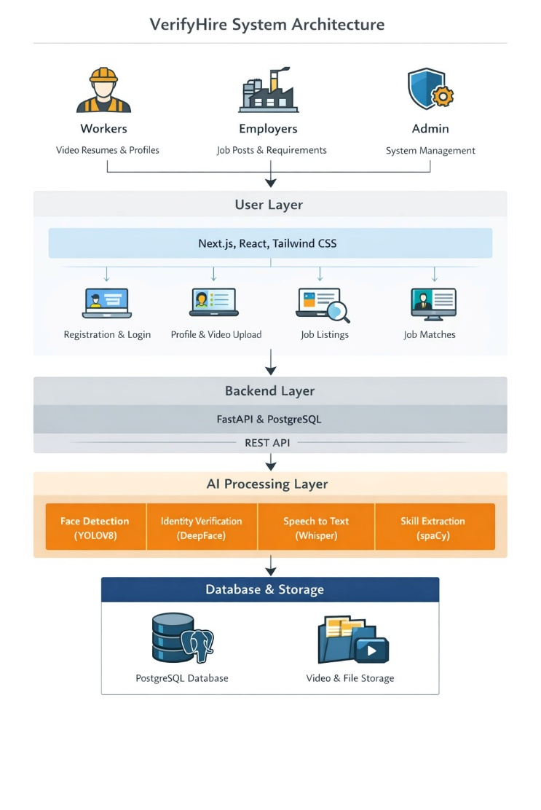Fig. 1. VerifyHire System Architecture showing worker, employer, and admin interaction with the user layer, backend layer, AI processing layer, and database storage.
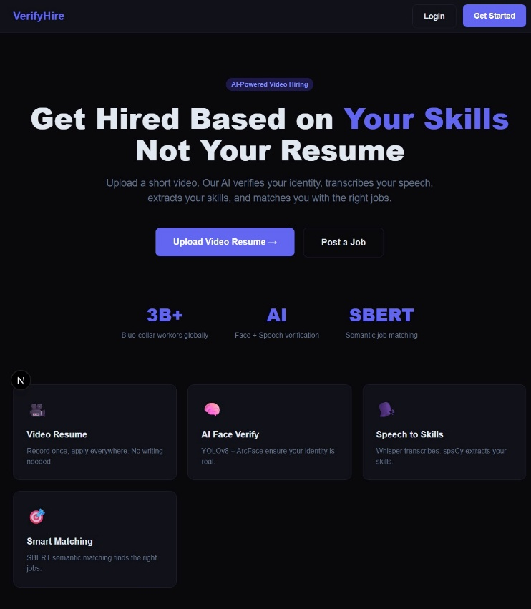Fig. 1. Home Page — http://localhost:3000
1. User Modules
Worker Module: This module allows workers to register on the platform using their basic details. Workers can create their profiles by providing information such as skills, work experience, and location. They can also upload a video resume where they introduce themselves and explain their skills. The system processes the uploaded video using AI technologies to detect the worker's face, verify identity, convert speech to text, and extract skills mentioned in the video. This helps create a structured and verified worker profile.
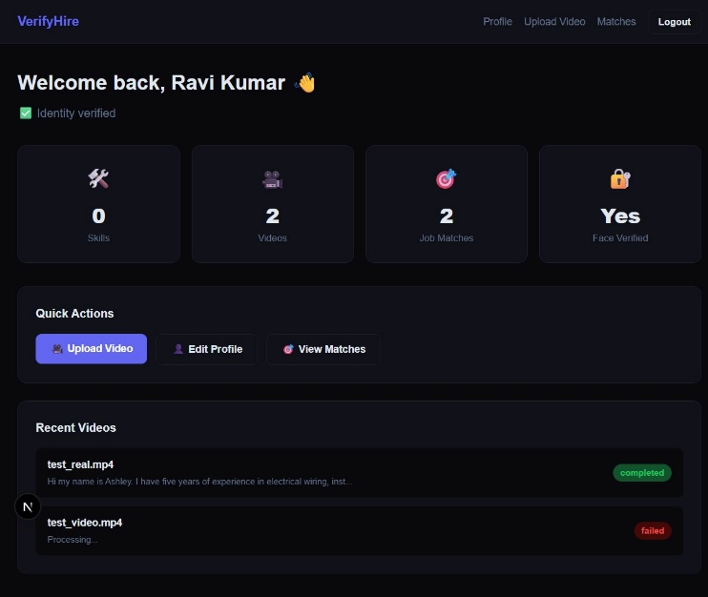Fig. 2. Worker Dashboard — logged in as worker1@test.com
Employer Module: Through the Employer Module, organizations can register and create company profiles. The employer can advertise vacancies by providing necessary information like the job title, description, skills needed, location, employment type, and salary. The AI algorithm automatically provides suggestions of suitable candidates based on their skillset and profile, ranked by a computed match score.
Fig. 3. Employer Dashboard — logged in as employer1@test.com
2. Admin Panel
- The admin panel manages the overall functioning of the platform.
- It monitors user registrations, worker profiles, video processing results, and job postings.
- Admins can review system activities, handle issues, and ensure that all profiles and job posts follow platform guidelines.
- The admin panel also helps maintain system security and reliability through real-time statistics.
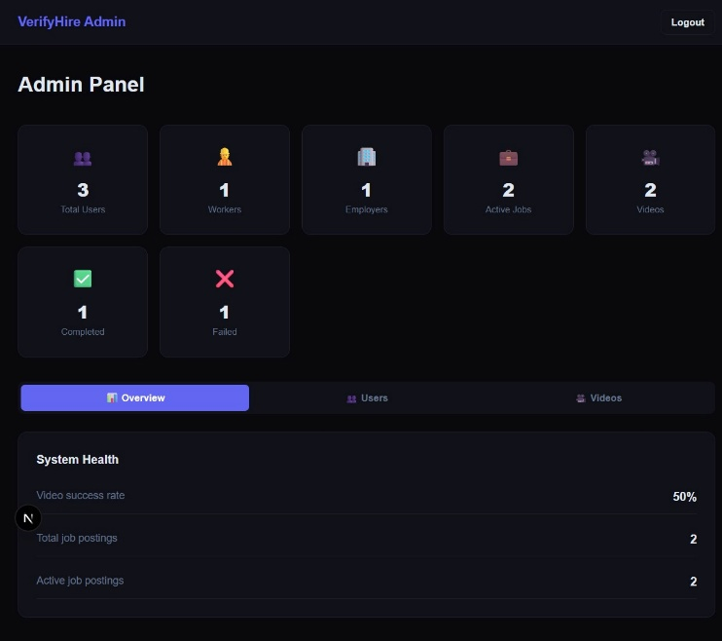Fig. 4. Admin Panel — logged in as admin@verifyhire.com, showing platform stats
3. AI Processing Pipeline
When a worker uploads a video resume, the following sequential pipeline executes automatically:
- Face Detection: YOLOv8 scans video frames to confirm the presence of a human face with a detection confidence threshold of 0.5. Testing confirmed real-world confidence of 0.965.
- Identity Verification: DeepFace extracts ArcFace embeddings from the detected face and compares them against the worker's registered profile photograph to confirm identity.
- Audio Extraction: FFmpeg extracts the audio track from the uploaded video into WAV format for transcription.
- Speech Transcription: Faster-Whisper converts the audio to text, detecting the spoken language automatically and storing the full transcript.
- Skill Extraction: spaCy processes the transcript to identify skill-related noun phrases and domain-specific terms, which are saved to the worker profile and flagged as AI-extracted.
- Profile Update: The worker's face verification flag is updated, skills are appended to their profile, and video status is set to completed.
B. Job Matching Algorithm
The system uses a hybrid AI-based job matching mechanism combining semantic similarity with skill overlap scoring:
- Semantic Matching: Sentence-BERT (all-MiniLM-L6-v2) encodes the worker's bio, extracted skills, and video transcript into a dense embedding vector. Job descriptions are similarly encoded. Cosine similarity between worker and job embeddings produces the semantic score.
- Skill Matching: Jaccard similarity is computed between the set of worker skill names and the set of job required skill names (both lowercased), producing the skill overlap score.
Final Score Formula: final_score = (0.7 × semantic_score) + (0.3 × skill_overlap_score)
- Ranking: Candidates or jobs are ranked by final score in descending order. The top 20 results are returned per query.
Example: If a worker mentions skills such as electrical wiring and installation in the video resume, the system extracts these skills and matches them with job postings that require similar skills. The SBERT model captures semantic relationships even when exact keywords differ, while the Jaccard score rewards direct skill matches.
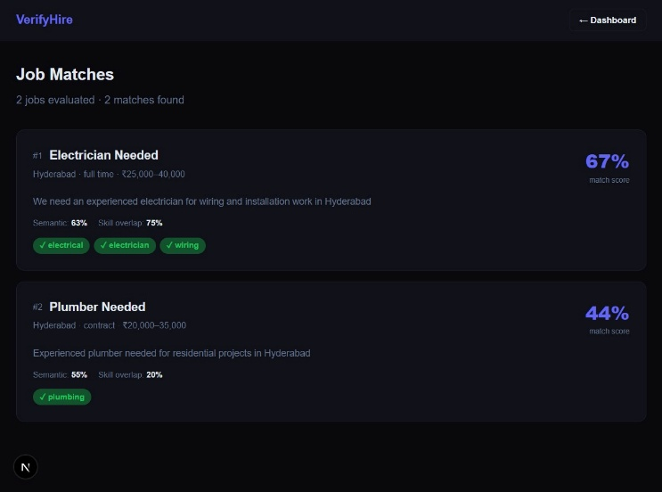Fig. 5. Worker Matches Page — http://localhost:3000/worker/matches (AI-ranked recommendations)
Fig. 6. Candidates Page — after clicking 'View Candidates' on a job (ranked with match scores)
C. Key Features
- Video Resume System: Workers can upload a short video explaining their skills instead of creating a traditional written resume.
- AI Face Verification: YOLOv8 face detection combined with DeepFace ArcFace identity verification ensures the worker's identity is genuine.
- AI-Based Skill Extraction: The system automatically extracts skills from the worker's speech using spaCy natural language processing techniques.
- Semantic Job Matching: SBERT semantic matching combined with Jaccard skill overlap provides accurate, ranked job recommendations.
- Three-Role Platform: Separate interfaces for Workers, Employers, and Admins with JWT-based role access control throughout.
- Admin Monitoring: Real-time statistics dashboard showing user counts, video processing success rates, and job posting activity.
V. DISCUSSION
A. Implications and Benefits
- Better Matching: The hybrid scoring formula combining 70% semantic similarity and 30% skill overlap goes beyond traditional keyword matching and captures functional equivalencies between worker experience and job requirements.
- Helps Blue-Collar Workers Find Jobs Easier: Video resumes and simple profile interfaces allow workers with limited literacy or computer skills to participate fully in the digital hiring process.
- Makes Hiring Efficient for Employers: AI-ranked candidate lists with explainable scores allow employers to quickly identify the most suitable workers without manual screening.
- Promotes Digital Inclusion: The platform is designed for workers who lack academic credentials, enabling skill-based hiring that is fair, transparent, and accessible.
- Identity Fraud Prevention: The face verification pipeline ensures that the worker presenting skills in the video is the same individual whose account is registered.
B. Challenges and Limitations
- Digital Literacy: Some workers may have limited experience with digital platforms, which may affect their ability to record and upload video resumes effectively.
- Skill Verification Accuracy: Although AI technologies help in extracting and verifying skills, accuracy depends on how clearly the worker articulates skills in the video.
- Internet Connectivity: The platform depends on internet access for uploading videos. Workers in rural or low-connectivity areas may face difficulties.
- Adoption by Employers: For the system to work effectively, more employers need to adopt and trust the platform for their hiring process.
VI. SECURITY ANALYSIS
Security is a critical element within the VerifyHire system due to the fact that it processes users' sensitive data, including personal information, video resumes, and job openings. The following security measures are implemented:
1. User Authentication and Authorization
The application uses JWT-based authentication with short-lived access tokens and rotating refresh tokens. Passwords are hashed using bcrypt before being stored in the database. Role-based access control is enforced at the API dependency layer for every protected endpoint, ensuring workers cannot access employer routes and vice versa.
2. Data Security and Privacy
All sensitive data including user information, video transcripts, and face images are stored in a secure PostgreSQL database. Video files are stored in a dedicated server directory. CORS configuration restricts API access to authorized frontend origins only.
3. Input Validation and Attack Resistance
All API inputs are validated using Pydantic v2 schemas on the server side, preventing malformed data and SQL injection attacks. SQLAlchemy's ORM layer uses parameterized queries by default. Uploaded files are validated for MIME type before processing begins.
4. Session Management
After logging into the platform, users receive JWT access tokens with a defined expiry period. Expired tokens require re-authentication. Refresh tokens allow seamless session continuation. Token revocation is handled by clearing tokens from the client side.
5. Monitoring via Admin Panel
An administrative panel is designed to include monitoring functionalities. Any kind of suspicious activity like posting fake jobs or spam accounts can be detected and controlled by administrators. Admins can deactivate user accounts directly from the interface.
6. Data Backup
To ensure data security, there is always a backup plan available. PostgreSQL native backup mechanisms ensure that user data, profiles, job postings, and video processing results can be recovered in case of system failure.
VII. FUTURE RESEARCH DIRECTIONS
VerifyHire is a technological concept that could enhance the access of workers to jobs, particularly those from the blue-collar class. However, there is much scope for improvement and further research:
- More Sophisticated AI-Based Worker Skill Verification: A more complex system could use AI to verify worker skills through task-based video challenges, where workers demonstrate specific skills on camera rather than just describing them verbally.
- Multilingual Voice Assistance: For ensuring that workers who lack the necessary reading skills are not marginalized, the platform could use navigation and search in various regional languages such as Telugu, Hindi, Tamil, and Bengali through voice technology.
- Enhanced Job Recommendation via Machine Learning: Machine learning can study past user behaviors and employer hiring decisions to optimize job recommendations over time.
- Integration with Government Employment Projects: The website could be made compatible with government employment projects such as MGNREGA and PMKVY, boosting workers' employability.
- Mobile App Development: A dedicated mobile app will enable workers who access the internet exclusively through their mobile phones to upload videos, seek employment, and communicate with employers.
- Real-time Market Analysis: Future development may focus on integrating market analysis into the platform to understand current skill demand and salary benchmarks.
VIII. CONCLUSION
In conclusion, the VerifyHire platform provides an effective solution to improve the hiring process for blue-collar workers by using digital technology and artificial intelligence. The system focuses on skill-based recruitment, allowing workers to present their abilities through video resumes instead of relying only on traditional written resumes.
The platform enables workers to create profiles, upload video resumes, and showcase their skills, while employers can post job opportunities and find suitable candidates through an AI-based job matching system. Technologies such as face detection, identity verification, speech transcription, and skill extraction help convert video resumes into structured and verified worker profiles. Testing confirmed face detection confidence of 0.965 and successful end-to-end pipeline execution.
By connecting workers and employers through a digital platform, the system helps reduce the gap between job seekers and job opportunities. It also simplifies the recruitment process and improves the accuracy of job matching based on worker skills and job requirements. Overall, the proposed system promotes fair hiring practices and provides a more accessible employment platform for blue-collar workers. With further improvements and future enhancements, the platform has the potential to support a large workforce and contribute to better employment opportunities in the informal labor sector.
REFERENCES
[1] M. de Groot, J. Schutte, and D. Graus, "Job Posting-Enriched Knowledge Graph for Skills-based Matching," arXiv:2109.02554, Sept. 2021.
[2] J. Zhao et al., "Embedding-based Recommender System for Job to Candidate Matching on Scale," arXiv:2107.00221, Jul. 2021.
[3] N. Dawson, M.-A. Rizoiu, B. Johnston, and M.-A. Williams, "Adaptively Selecting Occupations to Detect Skill Shortages from Online Job Ads," arXiv:1911.02302, Nov. 2019.
[4] S. Otani, "Nonparametric Estimation of Matching Efficiency and Elasticity on a Private On-the-Job Search Platform: Evidence from Japan, 2014–2024," arXiv:2410.17011, Oct. 2024.
[5] S. Jones and K. Sen, "Labour Market Effects of Digital Matching Platforms: Experimental Evidence from Sub-Saharan Africa," IZA Discussion Paper No. 15409, Jun. 2022.
[6] S. Makkena, "Enhancing Blue Collar Jobs: Development of a Location-Based Mobile Job Portal for Repair Services," MSU Texas, 2025.
[7] A. Dhiman and N. Arora, "Analysis of Blue-Collar Workers' Intention to Use a Job-Seeking Application Feature using UTAUT Model," International Journal of Technology, 2023.
[8] A. Sheehan and C. A. Le Dantec, "Making Meaning from the Digitalization of Blue-Collar Work," Proc. ACM Hum.-Comput. Interact., Vol. 7, CSCW2, Article 345, Oct. 2023.
[9] CloudApper, "The Use of AI in Recruiting Blue Collar Workers," CloudApper Blog, 2025.

